Install docker on EC2 and explore the docker commands (docker images, containers, volumes, network)

**Step 01** – verified whether docker is installed or not

docker --version

**Step 02** – Installing docker in EC2 Instance

1. Update the package manager:

sudo yum update -y

1. Install Docker:

sudo yum install docker -y

1. Verifying whether the docker has been installed or not

docker --version

**Step 03** - Explore the docker commands (docker images, containers, volumes, network)

***Image Commands:***

1. docker image

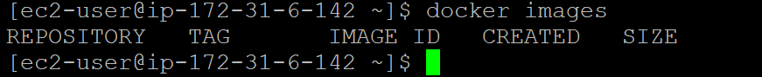

At first, there were no images available, but after pulling a few images, the Docker image command...

***Containers Commands:***

1. docker run command

1. docker ps & docker ps -a commands

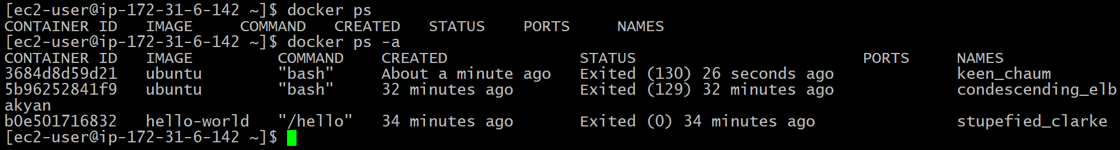

1. docker remove command

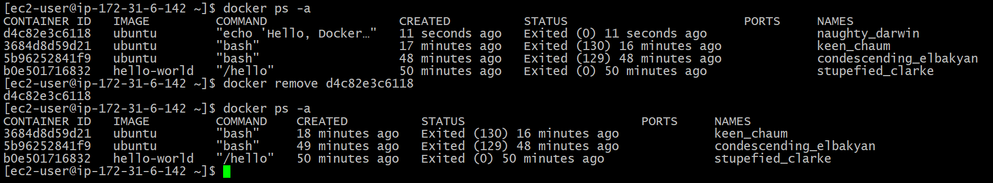

1. docker stop & docker rm commands

***Volume Commands:***

1. docker volume create & list commands

1. docker volume inspect command

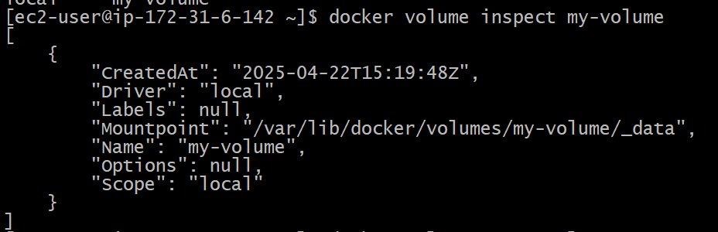

1. docker remove command

**Network Commands:**

1. docker network ls command

1. docker network create command

1. docker network inspect command

1. docker network rm command

